Network Devices (Hub, Repeater, Bridge, Switch, Router, Gateways and Brouter)

**1. Repeater** – A repeater operates at the physical layer. Its job is to regenerate the signal over the same network before the signal becomes too weak or corrupted so as to extend the length to which the signal can be transmitted over the same network. An important point to be noted about repeaters is that they do not amplify the signal. When the signal becomes weak, they copy the signal bit by bit and regenerate it at the original strength. It is a 2 port device.

**2. Hub** –  A hub is basically a multiport repeater. A hub connects multiple wires coming from different branches, for example, the connector in star topology which connects different stations. Hubs cannot filter data, so data packets are sent to all connected devices.  In other words, [collision domain](https://en.wikipedia.org/wiki/Collision_domain) of all hosts connected through Hub remains one.  Also, they do not have intelligence to find out best path for data packets which leads to inefficiencies and wastage.

**Types of Hub**

* **Active Hub:-**These are the hubs which have their own power supply and can clean, boost and relay the signal along with the network. It serves both as a repeater as well as wiring centre. These are used to extend the maximum distance between nodes.
* **Passive Hub :-**These are the hubs which collect wiring from nodes and power supply from active hub. These hubs relay signals onto the network without cleaning and boosting them and can’t be used to extend the distance between nodes.

**3. Bridge** – A bridge operates at data link layer. A bridge is a repeater, with add on the functionality of filtering content by reading the MAC addresses of source and destination. It is also used for interconnecting two LANs working on the same protocol. It has a single input and single output port, thus making it a 2 port device.

**Types of Bridges**

* **Transparent Bridges:-**These are the bridge in which the stations are completely unaware of the  
  bridge’s existence i.e. whether or not a bridge is added or deleted from the network, reconfiguration of  
  the stations is unnecessary. These bridges make use of two processes i.e. bridge forwarding and bridge learning.
* **Source Routing Bridges:-**In these bridges, routing operation is performed by source station and the frame specifies which route to follow. The hot can discover frame by sending a special frame called discovery frame, which spreads through the entire network using all possible paths to destination.

**4. Switch** – A switch is a multiport bridge with a buffer and a design that can boost its efficiency(a large number of ports imply less traffic) and performance. A switch is a data link layer device. The switch can perform error checking before forwarding data, that makes it very efficient as it does not forward packets that have errors and forward good packets selectively to correct port only.  In other words, switch divides collision domain of hosts, but [broadcast domain](https://en.wikipedia.org/wiki/Broadcast_domain) remains same.

**5.****[Routers](https://www.geeksforgeeks.org/network-devices-hub-repeater-bridge-switch-router-gateways/" \l "Routers)** – A router is a device like a switch that routes data packets based on their IP addresses. Router is mainly a Network Layer device. Routers normally connect LANs and WANs together and have a dynamically updating routing table based on which they make decisions on routing the data packets. Router divide broadcast domains of hosts connected through it.

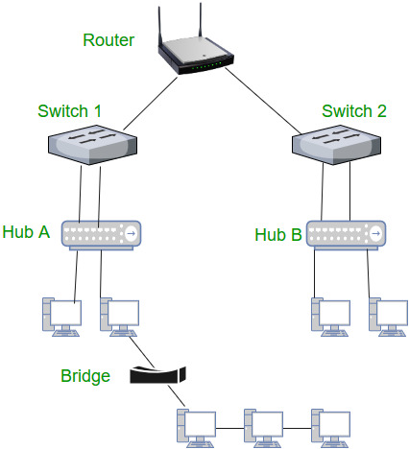

**6. Gateway** – A gateway, as the name suggests, is a passage to connect two networks together that may work upon different networking models. They basically work as the messenger agents that take data from one system, interpret it, and transfer it to another system. Gateways are also called protocol converters and can operate at any network layer. Gateways are generally more complex than switch or router.

| **Hub** | **Router** |
| --- | --- |
| **Layer** | Physical layer. Hubs are classified as Layer 1 devices per the OSI model. | Network Layer (Layer 3 devices) |
| **Function** | To connect a network of personal computers together, they can be joined through a central hub. | Directs data in a network. Passes data between home computers, and between computers and the [modem](https://www.diffen.com/difference/Modem_vs_Router). |
| **Data Transmission form** | Electrical signal or bits | Packet |
| **Ports** | 4/12 ports | 2/4/5/8 |
| **Transmission Type** | Hubs always perform frame flooding; may be unicast, multicast or broadcast | At Initial Level Broadcast then Uni-cast & Multicast |
| **Device Type** | Passive Device (Without Software) | Networking device |
| **Used in (LAN, MAN, WAN)** | LAN | LAN, MAN, WAN |
| **Table** | A network hub cannot learn or store MAC address. | Store IP address in Routing table and maintain address at its own. |
| **Transmission Mode** | Half duplex | Full duplex |
| **Broadcast Domain** | Hub has one Broadcast Domain. | In Router, every port has its own Broadcast domain. |
| **Definition** | An electronic device that connects many network device together so that devices can exchange data | A router is a networking device that connects a local network to other local networks. At the Distribution Layer of the network, routers direct traffic and perform other functions critical to efficient network operation. |
| **Speed** | 10Mbps | 1-100 Mbps (Wireless); 100 Mbps - 1 Gbps (Wired) |
| **Address used for data tramsmission** | Uses MAC address | Uses IP address |
| **Necessary for Internet Connection?** | No. | No, but provides [additional security](https://www.diffen.com/difference/WPA_vs_WPA2) and allows for multiple connections. |
| **Device Category** | non intelligent device | Intelligent Device |
| **Manufacturers** | Sun Systems, Oracle and Cisco | Cisco, Netgear, Linksys, Asus, TP-Link, D-Link |

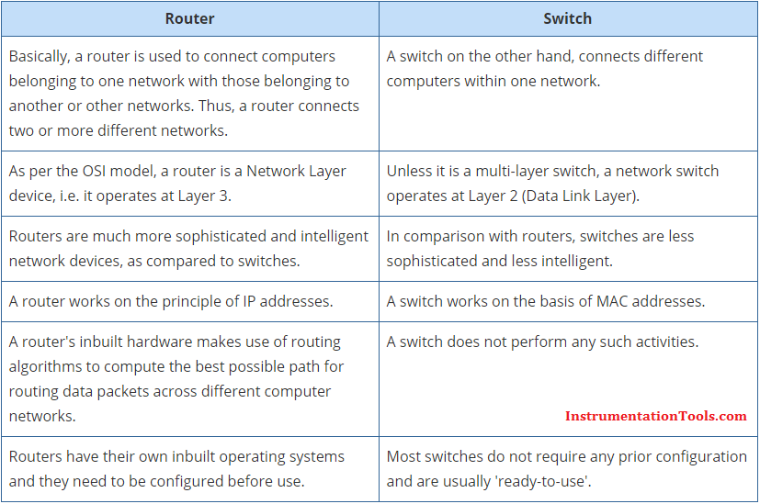

|  |  |
| --- | --- |
| **Routers** | **Bridges** |
| Routers operate in the network layer of [OSI Model](https://www.learnabhi.com/osi-model-computer-network/). | Bridge operates in data link layer of OSI Model. |
| The router is used to connect the [LAN and WAN](https://www.learnabhi.com/difference-between-lan-can-man-and-wan/). | The bridge is used to connect two different LAN segments. |
| The router transmits data in the form of packets. | Bridge transmit data in the form frames. |
| It reads the [IP Address](https://www.learnabhi.com/ip-address/) of a device. | Bridge reads the [MAC Address](http://searchnetworking.techtarget.com/definition/MAC-address) of a device. |
| The router has more ports compare to bridge. | The bridge has only two ports. |
| It uses routing table for sending data. | The bridge does not use any routing table for sending data. |
| It works on more than one broadcast domain. | It works on a single broadcast domain. |
| Routers use a software-configured network address to determine the address. | Bridges determine the destination address with the help of the MAC address of the device. |
| It communicates with other routers to decide the best way to transfer the data. | With the help of MAC addresses of the devices, the Bridges listen to the network traffic and then decide the way to send the data. |
| The router creates multiple paths to send data. | The bridge does not create multiple paths to send data. |
| You can configure [protocols](https://www.learnabhi.com/tcp-ip-protocol-port-number/) such as RIP, IGRP, OSPF, etc in a router. | You cannot configures any routing protocols in a bridge. |

